

**A**

**PROJECT REPORT**

**ON**

**“INVENTORY MANAGEMENT SYSTEM”**

**SUBMITED**

**TO**

**SAVITRIBAI PHULE PUNE UNIVERSITY, PUNE**

**FOR THE AWARD OF**

**MASTER OF COMPUTER APPLICATION**

**(MCA-III, SEM.-V)**

**BY**

**SHIVANI SANTOSH JADHAV**

**UNDER THE GUIDANCE OF**

**PROF. NAVNATH CHOUDHARI SIR.**

**THROUGH**

**THE DIRECTOR**

**SINHGAD INSTITUTE OF MANAGEMENT AND COMPUTER APPLICATION (SIMCA), NARHE, PUNE**

**(AY. 2021-2022)**

|  |  |  |  |  |
| --- | --- | --- | --- | --- |
|  | **SINHGAD TECHNICAL EDUCATION SOCIETY’S**  **SINHGAD INSTITUTE OF**  **MANAGEMENT & COMPUTER APPLICATION**  **(Affiliated to Savitribai Phule Pune University & Appoved by AICTE)**  **‘NAAC’ Accredited with ‘A’ Grade** | | |  |
| **S. No. 49/1, Off Westernly Bypass, Pune – Mumbai Expressway, Narhe, Pune – 411041, Tel : (020) 66831896 / 66831908 / 66831907**  **E-mail : director_mca_simca@sinhgad.edu Website : www.sinhgad.edu** | | | | |
| **Prof. M. N. Navale**  M.E. (Elec), MIE, MBA  FOUNDER PRESIDENT | | **Dr. (Mrs.) Sunanda M. Navale**  B.A., P.P.M., Ph.D.  FOUNDER SECRETARY | **Dr. Vilas Nandavadekar** M.C.A., M.P.M., M.B.A., Ph. D.DIRECTOR, SIMCA - MCA | |

**CERTIFICATE**

This is to certify that, the project entitled “**Inventory Management System”,** being submitted for the award of the degree of **Master of Computer Application** by her to **Sinhgad Institute of Management and Computer Application affiliated to Savitribai Phule Pune University, Pune** is the result of the original work completed by ***Shivani Santosh Jadhav*** under the guidance of ***Prof Navnath Choudhari sir***.

To the best of our knowledge and belief, this work has not been previously submitted by the award of any degree or diploma of Savitribai Phule Pune University or any other University.

PLACE:

DATE:

**Prof. Navnath Dr. Rajesh Gawali Dr.Vilas Nandawadeker**

**Choudhari**

**Internal Guide Project Co-Ordinator Director SIMCA-MCA**

**External Examiner**

**DECLARATION**

I, the undersigned hereby declare that the project titled “Inventory Management System**”,** being submitted for the award of degree of **Master of Computer Application** by me to  **Shinhgad Institute of Management and Computer Application(SIMCA) affiliated to Savitribai Phule Pune University** is the result of an independent work carried out under the guidance of **Prof. Navnath Choudhari Sir.,** is my original work . Further I declare that this project has not been submitted to this or any Institution for the award of any degree.

PLACE: PUNE Student Name

DATE:

(Shivani Santosh Jadhav)

**ACKNOWLEDGEMENT**

The project developed for the MCA was not possible without the persons and organizations that helped me in completing this. I am deeply grateful to all whose enthusiasm and energy transformed my vision of this study into reality.

I extend my sincere thanks to Mr.________________ from Company name for making it easy to work in the organization and providing me needed guidance throughout the project keeping it focused and on the track. I am really thankful to him for the extended knowledge imparted to me during the course of project development.

I take this opportunity to thank my guide **Prof Navnath Choudhari sir**, project coordinator **Dr. Rajesh Gawali** and our Director **Dr. Vilas Nandawadaker**, for encouragement and guidance throughout the progress of this report.

**Shivani Santosh Jadhav**

**Index**

|  |  |
| --- | --- |
| **Sr.No** | **Contents** |
| **1.** | **Introduction** |
|  | Introduction to System |
|  | Existing System |
|  | Proposed System |
|  | Scope of the System |
| **2.** | **Analysis** |
|  | Fact Finding Techniques |
|  | Feasibility Study |
|  | Functional and non-functional requirements |
|  | Hardware and software Requirements |
| **3.** | **System Design** |
|  | E-R Diagram |
|  | Use Case Diagram |
|  | DFD Diagram |
|  | Class Diagram |
|  | Object Diagram |
| **4.** | **Table Design** |
| **5.** | **Module Design** |
| **6.** | **Form Design** |
| **7.** | **Testing** |
| **8.** | **Future Enhancement** |
| **9.** | **Conclusion** |
| **10.** | **Bibliography** |
| **11.** | **Annexure** |

**Introduction**

**Introduction to System:-**

The project titled "Inventory management System" is Inventory management software for monitoring and controlling the transactions in a Firm. The project “Inventory management System" is developed in python, which mainly focuses on basic operations in a Firm like Managing employee information, supplier information, Product and managing sales.

  “Inventory management System" is a desktop application, designed to help users maintain and organize Inventory of firm. Our software is easy to use for both beginners and advanced users. It features a familiar and well thought-out, an attractive user interface, combined with strong insertion and updating capabilities.

  The software Inventory management System" has four main modules. Insertion to Database Module – User friendly input screen, Extracting from Database module – Attractive Output Screen

The “Inventory management System"  has been developed to override the problem prevailing in the practicing manual system. This software is supported to eliminate and in some cases reduce the hardships faced by this existing system. Moreover this system is designed for the particular need of the Firm to carry out operations in a smooth and effective manner.

This website is very dynamic and very easy to understand, the interface of the website is very easy and anybody can easily work in our website, this website can provide all the details about Employee, supplier, sales and product and also useful for keeping track of all these categories on one Interface.

**Existing System:-**

The existing system is manual due to which there area complications while switching to different documents as well as generating reports. The existing system consists of following;

* At the record are to be manually maintain it consumes lot of time.
* Lot of paper work is involved as the record is maintained in the files and register.
* As file and register are used the space requirement is increased.
* Use of paper for storing valuable data information is not all reliable.
* It is very difficult to update or maintain all records.
* The existing system forces us to do all the tasks manually via paperwork which is outdated.

**Proposed System:-**

## Proposed system is an automated Inventory management System. Through our software Firm Owner can keep record of employee, view their information, easy to search for sales and keep track of products, update information, and edit information in quick time. Our proposed system has the following advantages.

## User friendly interface

## Fast access to database

## Less error

## Look and Feel Environment

## Quick transaction

## All the manual difficulties in managing the Firm have been rectified by implementing computerization.

**Scope of the System:-**

It manages all the information about Employees, Sales , Products. The purpose of the project is to build an application program to reduce the manual work for managing the Firm. It tracks all the details about the Employees, Sales, Products and suppliers.

**Functionalities provided by Inventory management System are as follows:**

* Inventory management System Provides the different types of department and co-ordinates them to take right decisions and reduces manual work with their all information.
* Manage the information of Department.

**Analysis**

**Fact Finding Techniques:-**

Information Gathering is not an easy task. We used specific methods to collect all the relative data about the system requirement called Fact finding Techniques.

* **Interview:**

Interview is one of the better techniques for information gathering where we directly understand the needs and proposals of the user. In this case, we’ve taken an interview of the owner of the inventory office & collected all the information about their current modules and desired system.

* **Questionnaires:**

We had the bank of questions regarding to the tours and travels system. We collected some data about the details of the workflow via this technique.

* **Observations:-**

Observation is the best technique where we can physically attend the proposed system. It also helps us to collect the data about user’s workflow, actual work & what can he enhance. In this case, we’ve visited the office to get the observations.

* **Record Review :-**

At least, the analyst reviews records of the existing system which may useful for new system. Observation provides data about how work is done, or actions are carried out.

**Feasibility Study:-**

**Feasibility Study:-**

Feasibility study carried out considering the following aspects.

1. **Economic Feasibility :-**

* It determines whether there are sufficient benefits in creating to make the cost acceptable or is the cost of the system too high so this signifies cost- benefits analysis and savings.
* We classify the cost of online service according to the type of service in which they occur.

1. **Technical Feasibility :-**

* It determines whether the work for the project can be done with the existing equipment, software technology and the available personals.
* It concerned with specifying equipment and the software that will satisfy the user equipment. This project is Feasible on technical remark also.

1. **Operational Feasibility:-**

* Operational feasibility criteria measure the urgency of the problem or the acceptability of solution. (Selection, acquisition & Design base)
* The unified modelling Language is a standard language for specifying, visualizing, constructing & documenting of the Software System.

**Functional Non-Functional Requirement:-**

* User should be allowed to claim their expenses related to official visits.
* System should support both domestic journeys and international journeys
* Expenses section should be categorized into two sub section as Travel Bill and Travel order.
* Order should allow a user to make ordering by employee himself and for request any advances before the tour.
* Relevant data can be entered to the system by him/herself or by a secretary
* System should cater at least 35 concurrent users.
* All the UI should be unique and running both IE and Firefox browsers.
* Support both English and Swedish languages.
* Reports are exported to different formats.
* Every caption should self explanation.

**Hardware and software Requirements:-**

**Software Requirement:**

* Operating System : Windows10
* Front End : python
* Back End : SQLite

**Hardware Requirement:**

* Processor : Intel core i3
* RAM : 4GB
* Hard Disk : 500GB
* printer

**System Design**

**E-R Diagram:-**

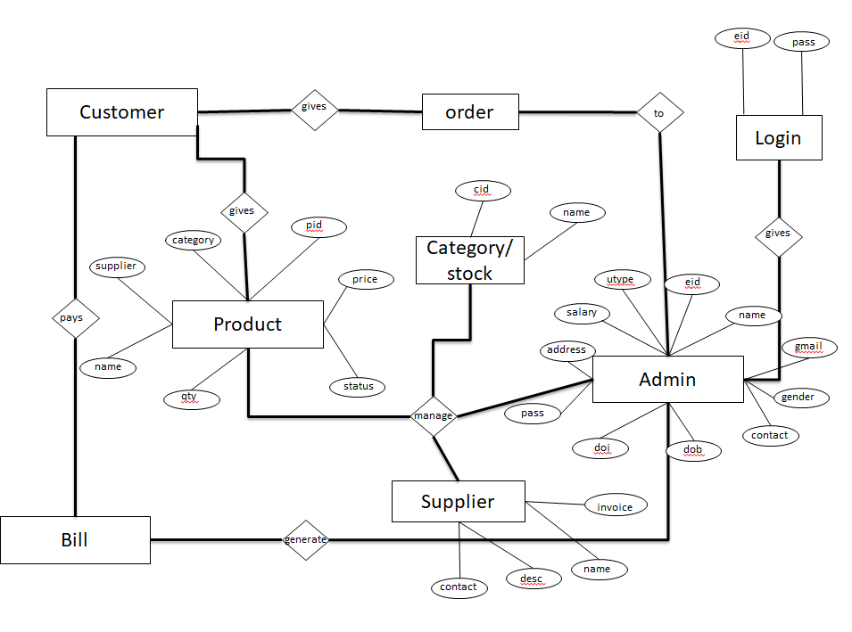

**Table Design**

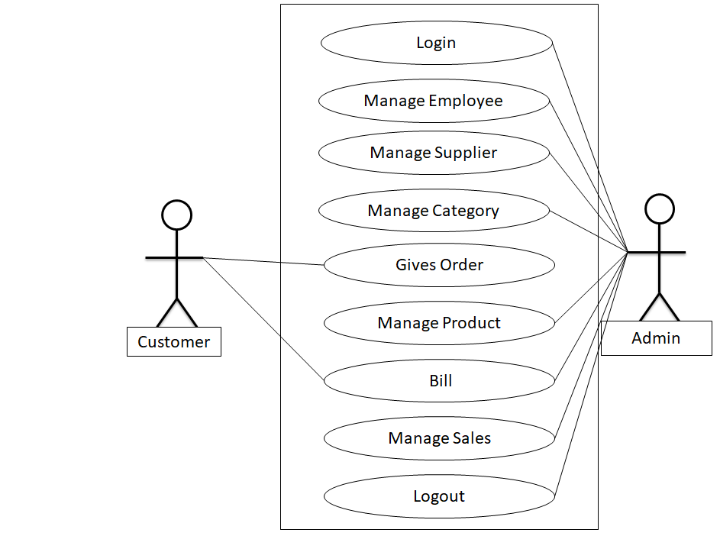**Use Case Diagram:- DFD Diagram:-**

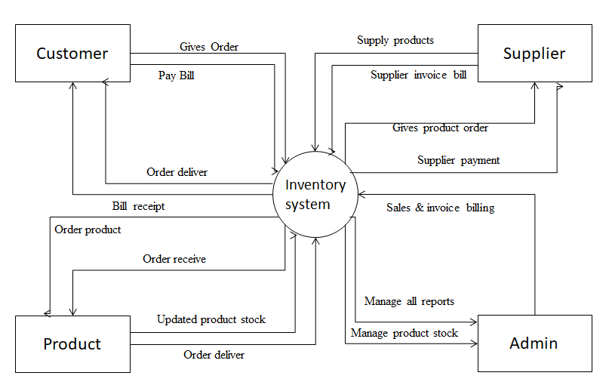

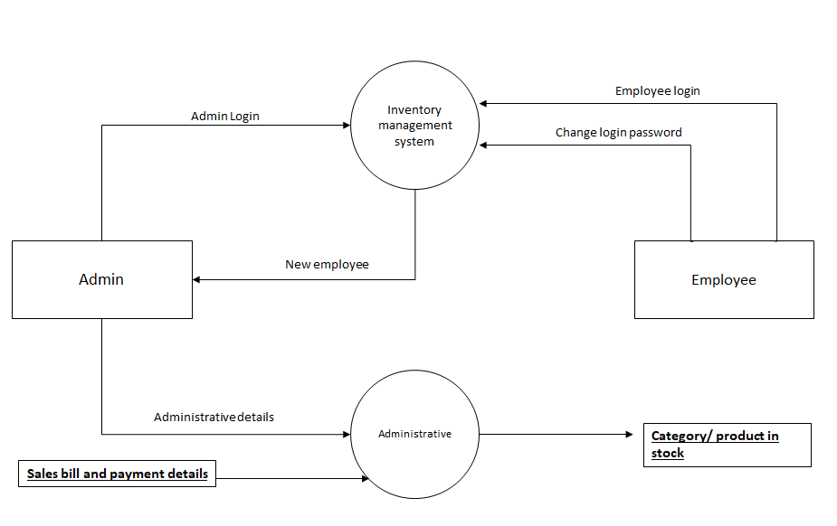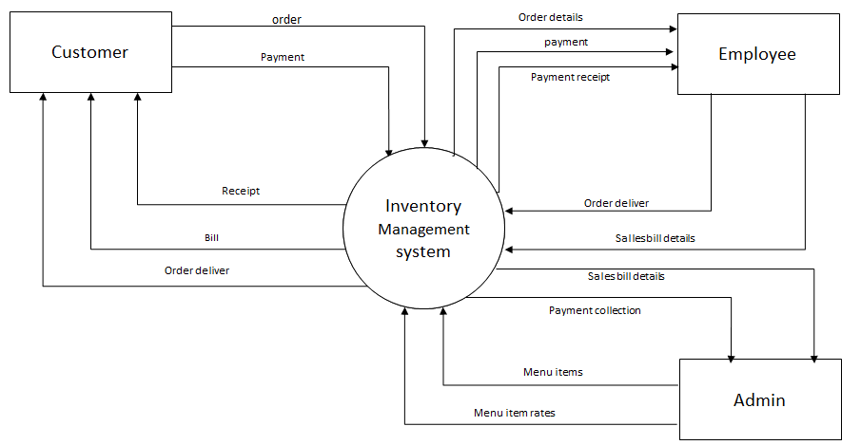

**Class Diagram :-**

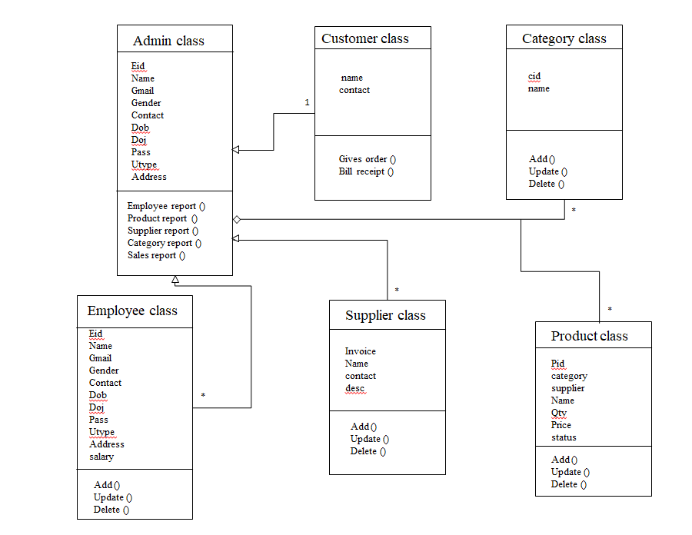

**Object Diagram:-**

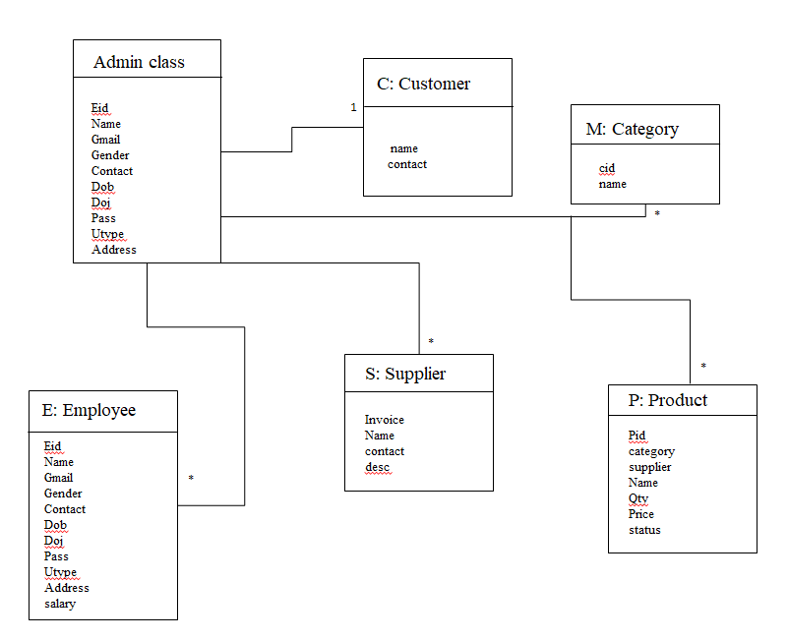

**Table Design**

**Employee Table**

|  |  |  |  |  |
| --- | --- | --- | --- | --- |
| **Fields** | **Data Type** | **Size** | **Constraints** | **Description** |
| **Eid** | **Int** | **5** | **Primary key** | **Employee id** |
| **name** | **Varchar** | **50** | **Not null** | **Employee name** |
| **Gmail** | **Varchar** | **50** | **Not null** | **Gmail** |
| **Gender** | **Varchar** | **20** | **Not null** | **Gender** |
| **Contact** | **Int** | **10** | **Not null** | **Phone no** |
| **Dod** | **Varchar** | **10** | **Not null** | **Date of birth** |
| **Doj** | **Varchar** | **10** | **Not null** | **Date of join** |
| **Pass** | **Int** | **8** | **Not null** | **Password** |
| **Utype** | **Varchar** | **20** | **Not null** | **User type** |
| **Address** | **Varchar** | **100** | **Not null** | **Address** |
| **Salary** | **int** | **5** | **Not null** | **Salary** |

**Category Table**

|  |  |  |  |  |
| --- | --- | --- | --- | --- |
| **Fields** | **Data Type** | **Size** | **Constraints** | **Description** |
| **cid** | **Int** | **5** | **Primary key** | **Category id** |
| **name** | **Varchar** | **50** | **Not null** | **category name** |

**Supplier Table**

|  |  |  |  |  |
| --- | --- | --- | --- | --- |
| **Fields** | **Data Type** | **Size** | **Constraints** | **Description** |
| **Invoice** | **Int** | **5** | **Primary key** | **Invoice number** |
| **Name** | **Varchar** | **50** | **Not null** | **Supplier name** |
| **contact** | **Varchar** | **10** | **Not null** | **Contact** |
| **Desc** | **Varchar** | **50** | **Not null** | **Description** |

**Product Table**

|  |  |  |  |  |
| --- | --- | --- | --- | --- |
| **Fields** | **Data Type** | **Size** | **Not null** | **Description** |
| **Pid** | **Int** | **5** | **Not null** | **Product id** |
| **Category** | **Varchar** | **50** | **Not null** | **Supplier name** |
| **SuppIier** | **Varchar** | **10** | **Not null** | **Contact** |
| **Name** | **Varchar** | **50** | **Not null** | **Description** |
| **Price** | **Int** | **5** | **Not null** | **Product price** |
| **Qty** | **Int** | **5** | **Not null** | **Product quantity** |
| **status** | **Varchar** | **50** | **Not null** | **Product status** |

**Module Design**

**Module Design:-**

1. User Module

* Login.
* Purchase product

2. Admin Module

* Manage employee.
* Manage supplier
* Manage category.
* Manage product.
* Manage sales.
* All reports

**Form Design**

**Login page**

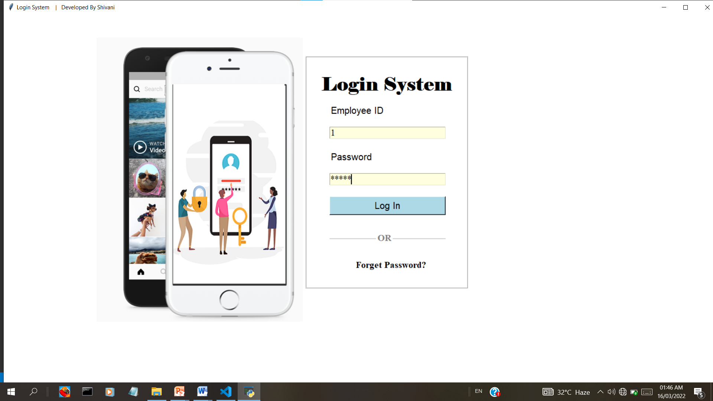 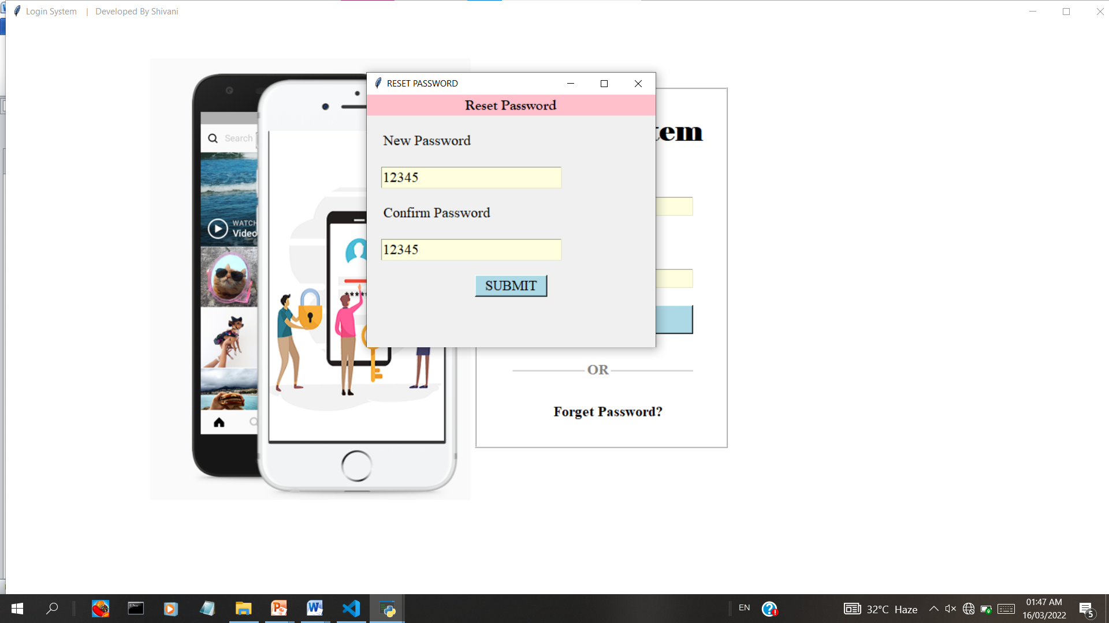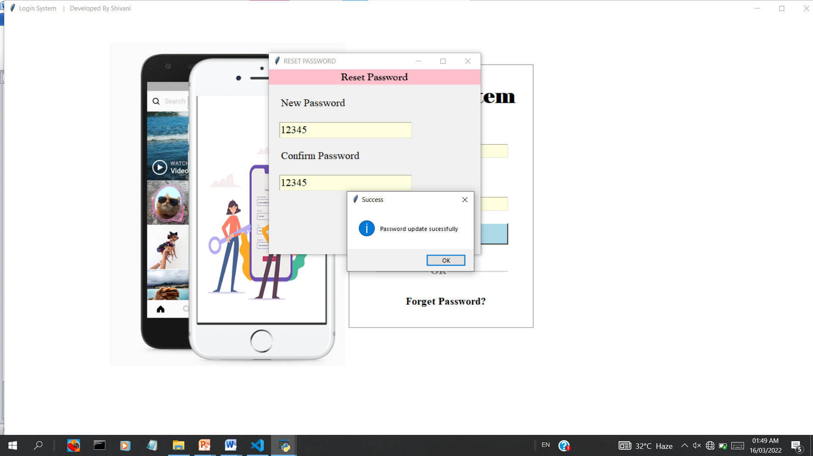

**Dashboard page**

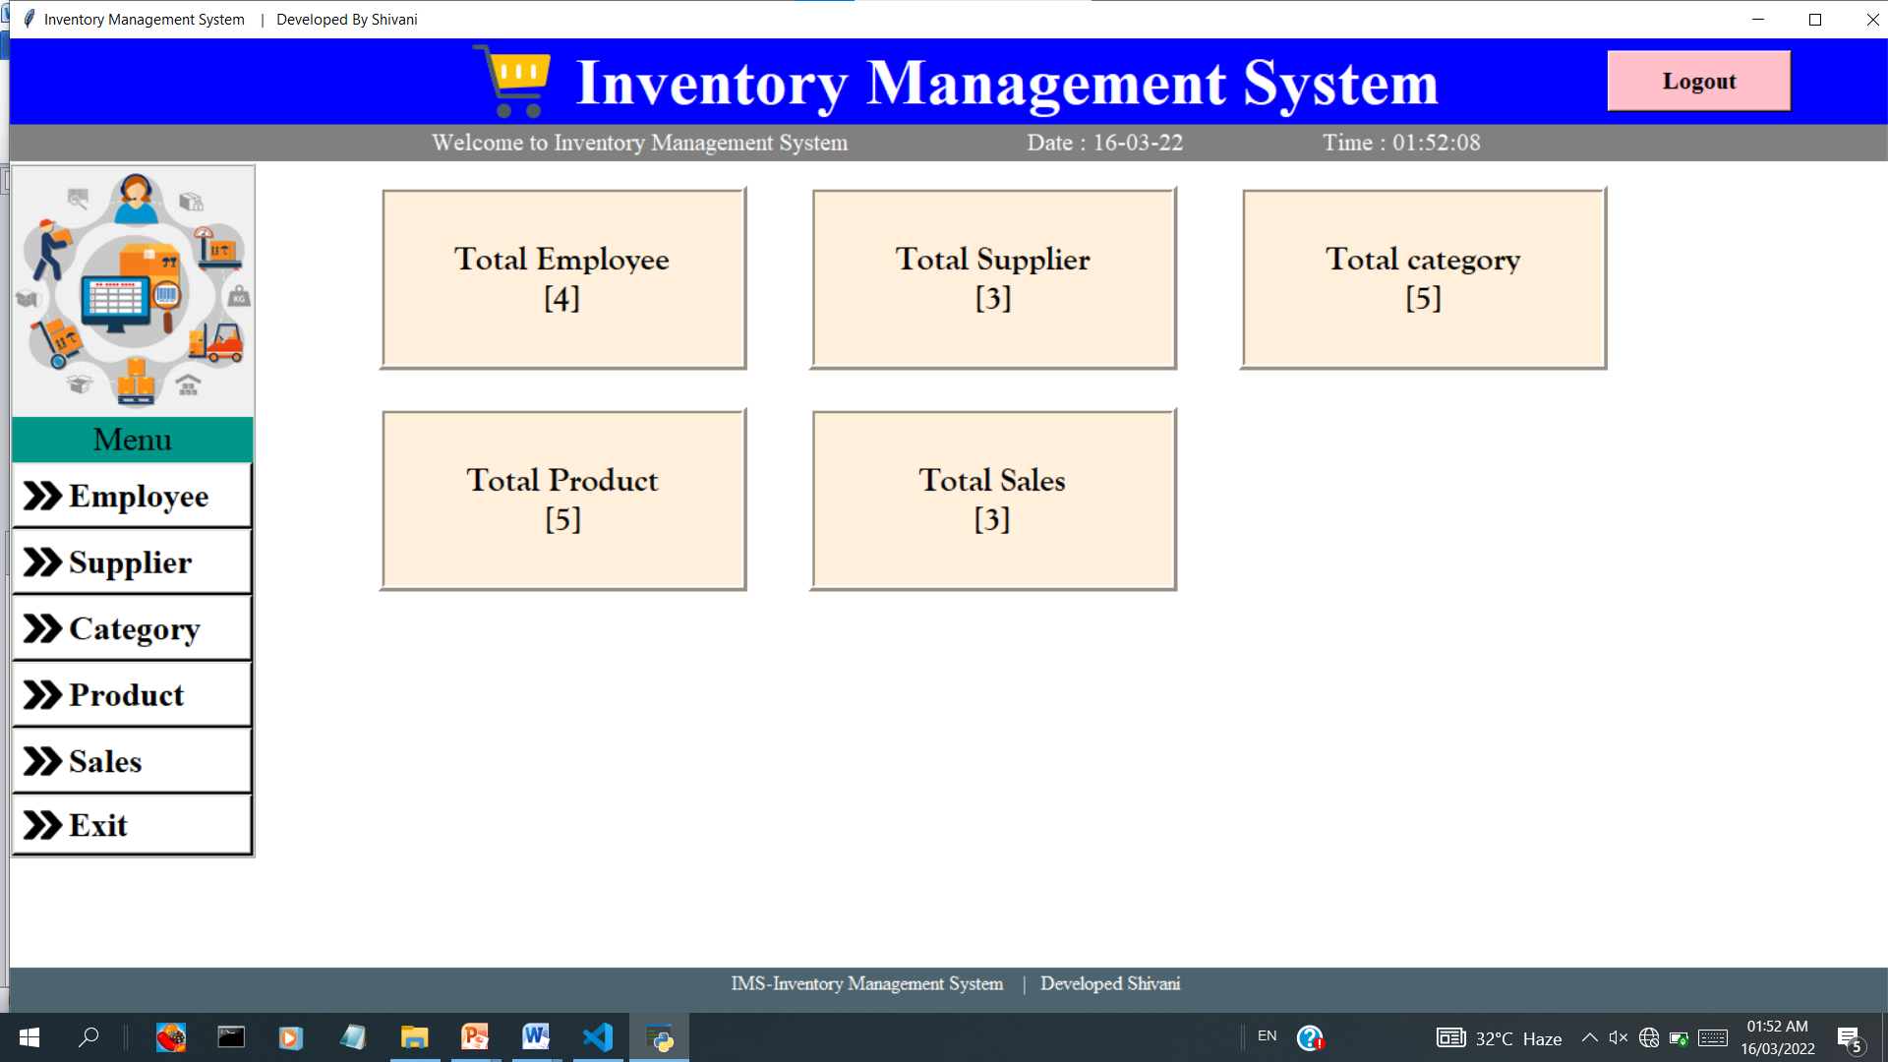

**Employee page**

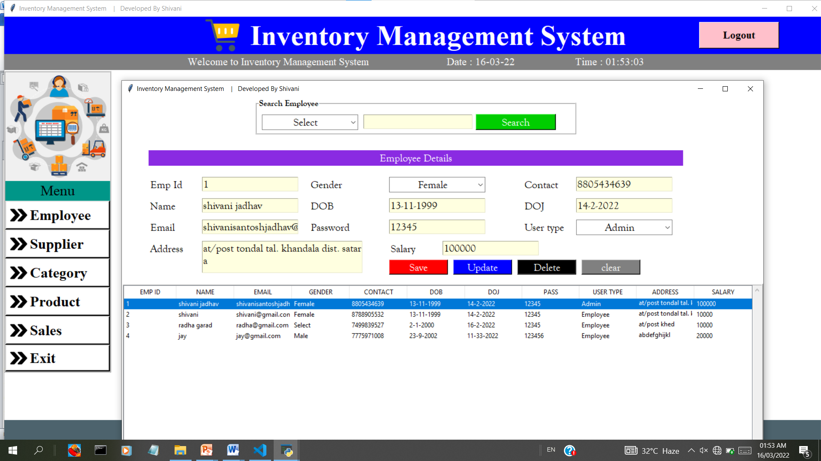

**Supplier page**

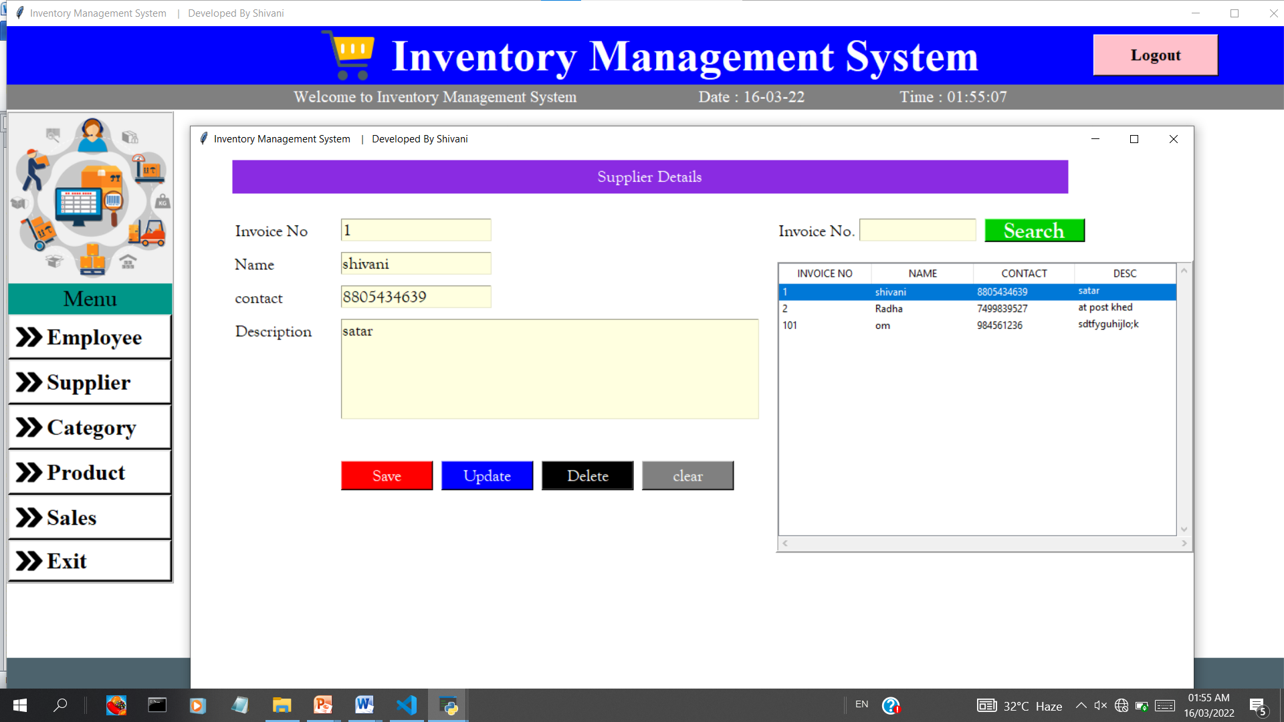

**Category page**

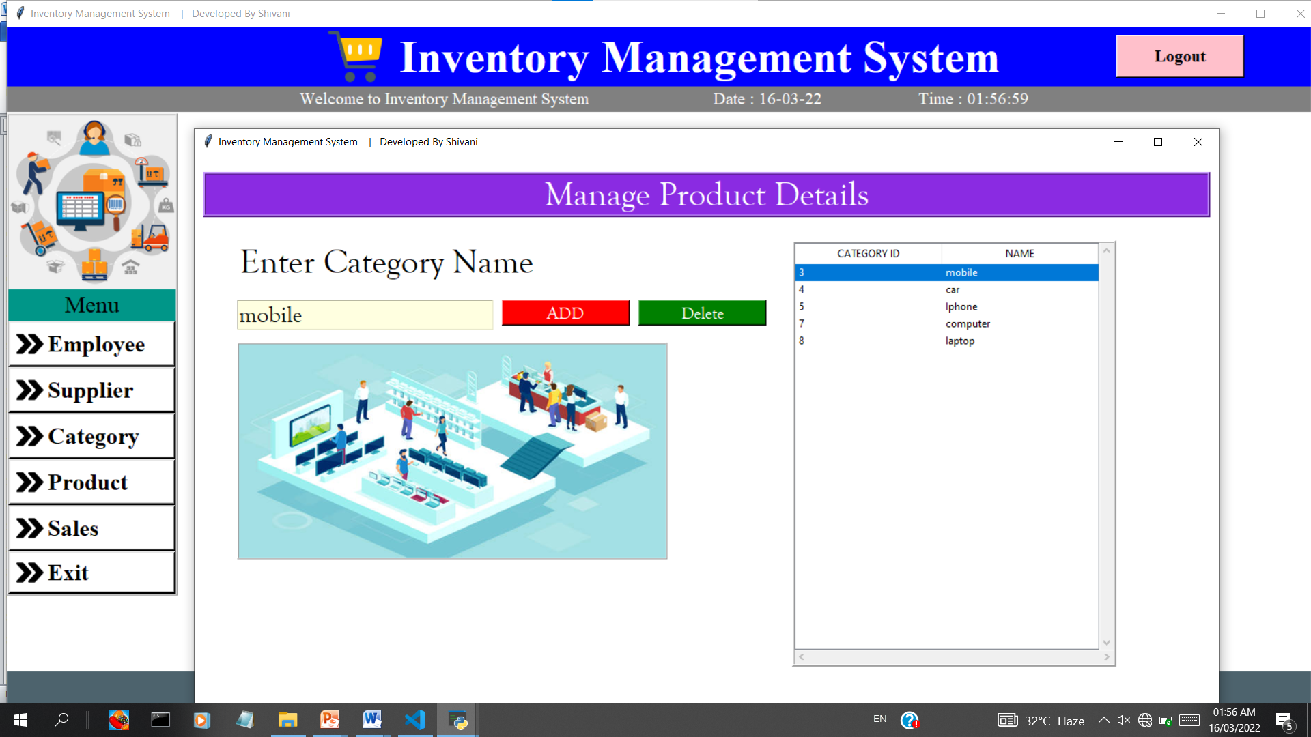

**Product page**

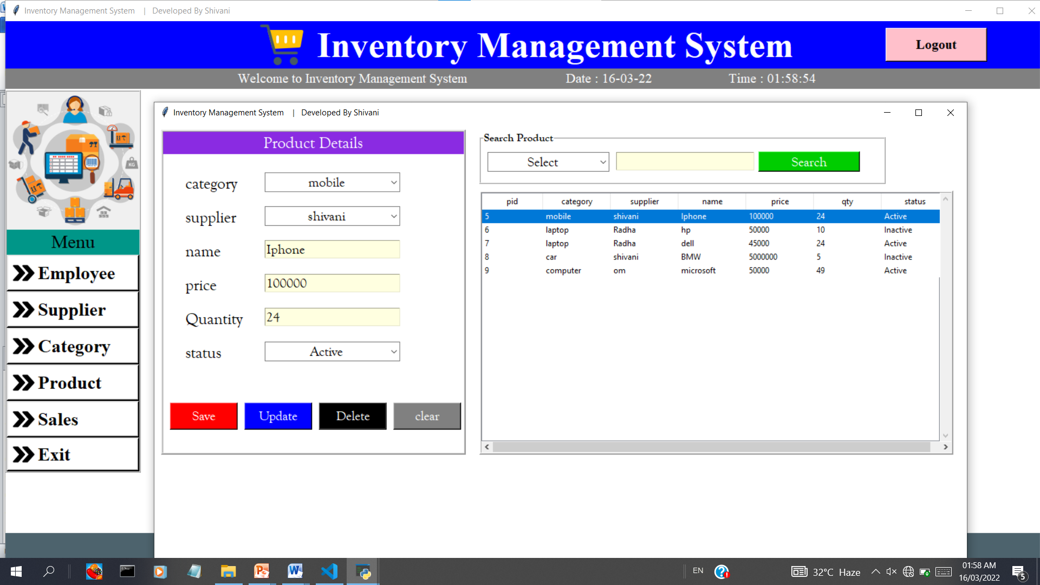

**Sales page**

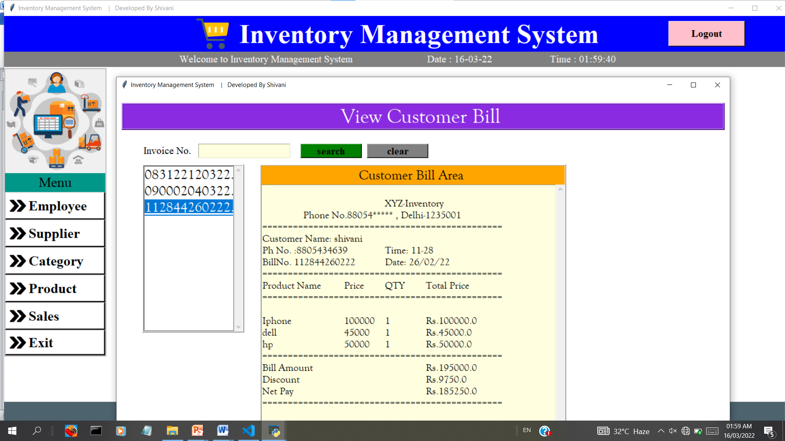

**Billing page**

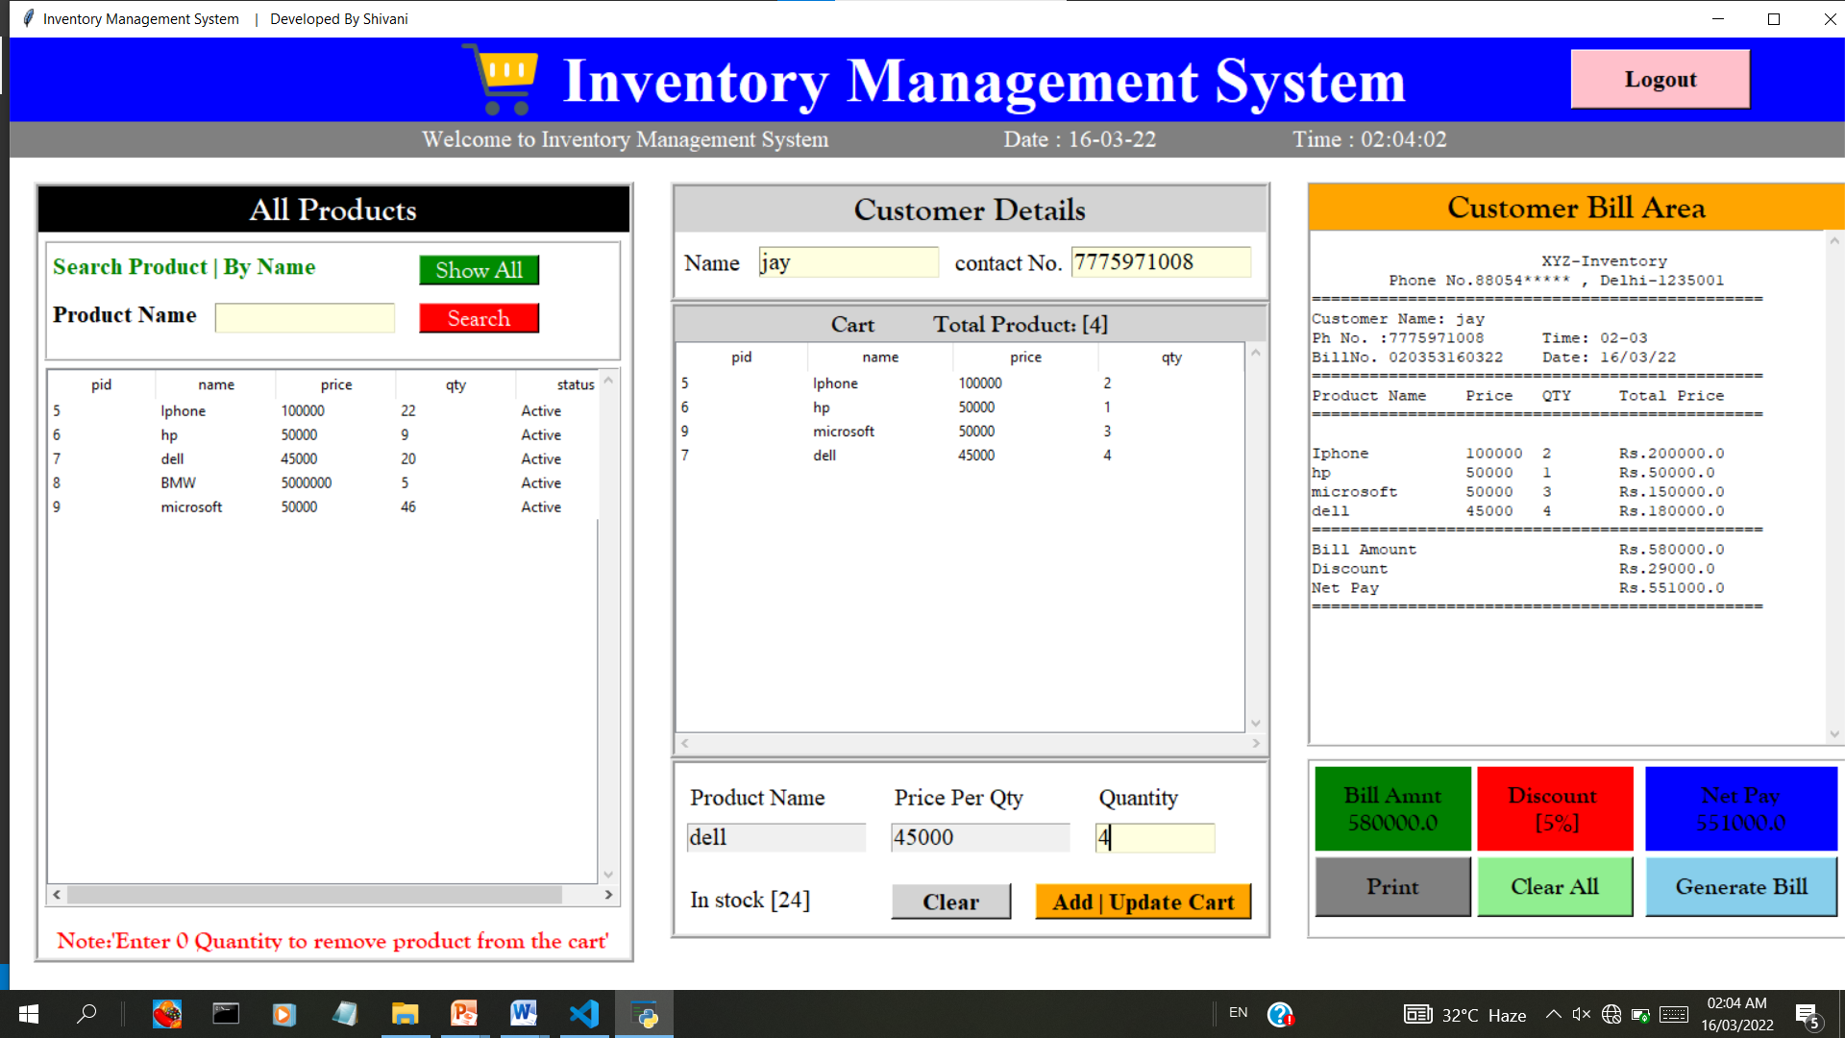

**Testing**

**Testing:-**

**Security Testing**

Testing is vital for the success of any software. No system design is ever perfect. Testing is also carried in two plans. First phase is during the software engineering that is during the module creation. Second phase is after the completion of software. This system testing which verifies the goal set of programs hanged together.

**White Box Testing**

In this techniques, the close examination of the logical part through the software are tested by case that exercise sets of conditions or loops. All logical parts of the software checked once.

**Black Box Testing**

This method enables the software engineer to device sets of input techniques that fully exercise all function requirements for program. Black Box Testing tests the inputs the output & the external data.

**Future Enhancement**

**Future Enhancement:-**

* Make the online payment system in application.
* Make the web base application in python.
* Forget password OPT received by mail id.
* Track the order location.
* This application can easy implement under various situation.

**Conclusion**

**Conclusion:-**

It was a great experience to design and implement the Inventory management System  by using Python and Sql Lite. And to work on its documentation. While working on this project I have learned many things especially how to apply the concept in different models. We learn with the working of different modules of Python and also with different libraries and use of  SQL lite.

**Bibliography**

**Bibliography:-**

* [www.w3layout.com](http://www.w3layout.com)
* [www.google.com](http://www.google.com).
* [www.chrome.com](http://www.chrome.com).
* [www.w3school.com](http://www.w3school.com)
* **You tube**
* **Python by Gourishankar**
* **The complete references**
* [tutorialspoint.com](https://www.tutorialspoint.com/index.htm)
* Programming by Mosh /Edurekha
* Coding with web coder

**Annexure:-**

from tkinter import*

from PIL import Image,ImageTk

from tkinter import ttk,messagebox

import sqlite3

import os

import time

from employee import employeeClass

from supplier import supplierClass

from category import categoryClass

from product import productClass

from sales import salesClass

class IMS:

    def __init__(self,root):

        self.root=root

        self.root.geometry("1600x800+0+0")

        self.root.title("Inventory Management System    |   Developed By Shivani")

        self.root.config(bg="white")

        #   title

        self.icon_title=PhotoImage(file="G:\IMS\images\logo1.png")

        title=Label(self.root,text="Inventory Management System",image=self.icon_title,compound=LEFT,font=("times new roman",40,"bold"),bg="blue",fg="white",padx=20).place(x=0,y=0,relwidth=1,height=70)

        btn_logout=Button(self.root,text="Logout",command=self.logout,font=("times new roman",15,"bold"),bg="pink",cursor="hand2").place(x=1300,y=10,height=50,width=150)

        self.lbl_clock=Label(self.root,text="Welcome to Inventory Management System\t\t Date : DD-MM-YYYY\t\t Time : HH:MM:SS",font=("times new roman",15),bg="gray",fg="white")

        self.lbl_clock.place(x=0,y=70,relwidth=1,height=30)

        #   menu

        self.MenuLogo=Image.open("images/menu_im.png")

        self.MenuLogo=self.MenuLogo.resize((200,200),Image.ANTIALIAS)

        self.MenuLogo=ImageTk.PhotoImage(self.MenuLogo)

        LeftMenu=Frame(self.root,bd=2,relief=RIDGE,bg="white")

        LeftMenu.place(x=0,y=102,width=200,height=565)

        lbl_menuLogo=Label(LeftMenu,image=self.MenuLogo)

        lbl_menuLogo.pack(side=TOP,fill=X)

        self.icon_side=PhotoImage(file="G:\IMS\images\side.png")

        lbl_menu=Label(LeftMenu,text="Menu",font=("times new roman",20),bg="#009688").pack(side=TOP,fill=X)

        btn_employee=Button(LeftMenu,text="Employee",command=self.employee,image=self.icon_side,compound=LEFT,padx=5,anchor="w",font=("times new roman",20,"bold"),bg="white",bd=3,cursor="hand2").pack(side=TOP,fill=X)

        btn_supplier=Button(LeftMenu,text="Supplier",command=self.supplier,image=self.icon_side,compound=LEFT,padx=5,anchor="w",font=("times new roman",20,"bold"),bg="white",bd=3,cursor="hand2").pack(side=TOP,fill=X)

        btn_category=Button(LeftMenu,text="Category",command=self.category,image=self.icon_side,compound=LEFT,padx=5,anchor="w",font=("times new roman",20,"bold"),bg="white",bd=3,cursor="hand2").pack(side=TOP,fill=X)

        btn_product=Button(LeftMenu,text="Product",command=self.product,image=self.icon_side,compound=LEFT,padx=5,anchor="w",font=("times new roman",20,"bold"),bg="white",bd=3,cursor="hand2").pack(side=TOP,fill=X)

        btn_sales=Button(LeftMenu,text="Sales",command=self.sales,image=self.icon_side,compound=LEFT,padx=5,anchor="w",font=("times new roman",20,"bold"),bg="white",bd=3,cursor="hand2").pack(side=TOP,fill=X)

        btn_exit=Button(LeftMenu,text="Exit",image=self.icon_side,compound=LEFT,padx=5,anchor="w",font=("times new roman",20,"bold"),bg="white",bd=3,cursor="hand2").pack(side=TOP,fill=X)

        self.lbl_employee=Label(self.root,text="Total Employee\n[ 0 ]",bd=5,relief=RIDGE,bg="antiquewhite1",fg="black",font=("goudy old style",20,"bold"))

        self.lbl_employee.place(x=300,y=120,height=150,width=300)

        self.lbl_supplier=Label(self.root,text="Total Supplier\n[ 0 ]",bd=5,relief=RIDGE,bg="antiquewhite1",fg="black",font=("goudy old style",20,"bold"))

        self.lbl_supplier.place(x=650,y=120,height=150,width=300)

        self.lbl_category=Label(self.root,text="Total Category\n[ 0 ]",bd=5,relief=RIDGE,bg="antiquewhite1",fg="black",font=("goudy old style",20,"bold"))

        self.lbl_category.place(x=1000,y=120,height=150,width=300)

        self.lbl_product=Label(self.root,text="Total Product\n[ 0 ]",bd=5,relief=RIDGE,bg="antiquewhite1",fg="black",font=("goudy old style",20,"bold"))

        self.lbl_product.place(x=300,y=300,height=150,width=300)

        self.lbl_sales=Label(self.root,text="Total Sales\n[ 0 ]",bd=5,relief=RIDGE,bg="antiquewhite1",fg="black",font=("goudy old style",20,"bold"))

        self.lbl_sales.place(x=650,y=300,height=150,width=300)

        lbl_footer=Label(self.root,text="IMS-Inventory Management System    |   Developed Shivani\n",font=("times new roman",12),bg="#4d636d",fg="white").pack(side=BOTTOM,fill=X)

        self.update_content()

#================================================================================

    def employee(self):

        self.new_win=Toplevel(self.root)

        self.new_obj=employeeClass(self.new_win)

    def supplier(self):

        self.new_win=Toplevel(self.root)

        self.new_obj=supplierClass(self.new_win)

    def category(self):

        self.new_win=Toplevel(self.root)

        self.new_obj=categoryClass(self.new_win)

    def product(self):

        self.new_win=Toplevel(self.root)

        self.new_obj=productClass(self.new_win)

    def sales(self):

        self.new_win=Toplevel(self.root)

        self.new_obj=salesClass(self.new_win)

    def update_content(self):

        con=sqlite3.connect(database=r'ims.db')

        cur=con.cursor()

        try:

            cur.execute("select * from employee")

            employee=cur.fetchall()

            self.lbl_employee.config(text=f'Total Employee\n[{str(len(employee))}]')

            cur.execute("select * from supplier")

            supplier=cur.fetchall()

            self.lbl_supplier.config(text=f'Total Supplier\n[{str(len(supplier))}]')

            cur.execute("select * from category")

            category=cur.fetchall()

            self.lbl_category.config(text=f'Total category\n[{str(len(category))}]')

            cur.execute("select * from product")

            product=cur.fetchall()

            self.lbl_product.config(text=f'Total Product\n[{str(len(product))}]')

            bill=len(os.listdir('bill'))

            self.lbl_sales.config(text=f'Total Sales\n[{str(bill)}]')

            time_=time.strftime("%I:%M:%S")

            date_=time.strftime("%d-%m-%y")

            self.lbl_clock.config(text=f"Welcome to Inventory Management System\t\t Date : {str(date_)}\t\t Time : {str(time_)}")

            self.lbl_clock.after(200,self.update_content)

        except Exception as ex:

            messagebox.showerror("Error",f"Error due to : {str(ex)}",parent=self.root)

    def logout(self):

        self.root.destroy()

        os.system("python login.py")

if __name__=="__main__":

    root=Tk()

    obj=IMS(root)

    root.mainloop()